# 1. INTRODUCTION

**1.1 Project Overview**

**1.2 Purpose**

# 2. IDEATION PHASE

**2.1 Problem Statement**

**2.2 Empathy Map Canvas**

**2.3 Brainstorming**

# 3. REQUIREMENT ANALYSIS

**3.1 Customer Journey Map**

**3.2 Solution Requirements**

**3.3 Data Flow Diagram**

**3.4 Technology Stack**

# 4. PROJECT DESIGN

**4.1 Problem-Solution Fit**

**4.2 Proposed Solution**

**4.3 Solution Architecture**

# 5. PROJECT PLANNING & SCHEDULING

**5.1 Project Planning**

# 6. FUNCTIONAL AND PERFORMANCE TESTING

**6.1 Performance Testing**

# 7. RESULTS

**7.1 Output Screenshots**

1. **ADVANTAGES & DISADVANTAGES**
2. **CONCLUSION**
3. **FUTURE SCOPE**
4. **APPENDIX**

**GitHub & Project Demonstration Link**

# 1. INTRODUCTION

## 1.1Project Overview

The Garage Management System aims to streamline and automate garage operations such as customer details, appointment date, service scheduling, billing, inventory management using Salesforce's cloud-based platform. The goal is to enhance efficiency, improve customer satisfaction, and provide real-time visibility of garage operations.﻿

## 1.2 Purpose

The purpose of the Garage Management System on the Salesforce Platform is to digitally transform and streamline the operational workflow of automotive service centers and garages, enhancing both operational efficiency and customer experience through automation, centralized data, and intelligent insights.

# 2. IDEATION PHASE

## 2.1 Problem Statement

|  |  |
| --- | --- |
| Date | 02 July 2025 |
| Team ID | LTVIP2025TMID31345 |
| Project Name | Garage Management System |
| Maximum Marks | 2 Marks |

Automotive garages and service centers struggle with fragmented workflows, manual processes, and lack of real-time visibility, leading to inefficiencies in appointment scheduling, technician assignment, inventory management, and customer communication. These issues result in lost productivity, missed revenue opportunities, poor customer experience, and limited decision-making capabilities. There is a critical need for an integrated, cloud-based solution that centralizes operations, automates repetitive tasks, and delivers actionable insights — all tailored to the unique demands of garage environments.

## 2.2 Empathy Map Canvas

|  |  |
| --- | --- |
| Date | 02 July 2025 |
| Team ID | LTVIP2025TMID31345 |
| Project Name | Garage Management System |
| Maximum Marks | 4 Marks |

### Section Description

**Think & Feel** Captures the user's internal thoughts, worries, aspirations, and priorities.

**Hear** Reflects what the user hears from friends, colleagues, influencers, or media.

**See** Describes the user's environment, what they observe, and what competitors offer.

**Say & Do** Outlines the user's behavior, public attitude, and how they interact with others.

**Pain** Identifies fears, frustrations, and obstacles the user faces.

**Gain** Highlights the user's goals, needs, and what success looks like to them.

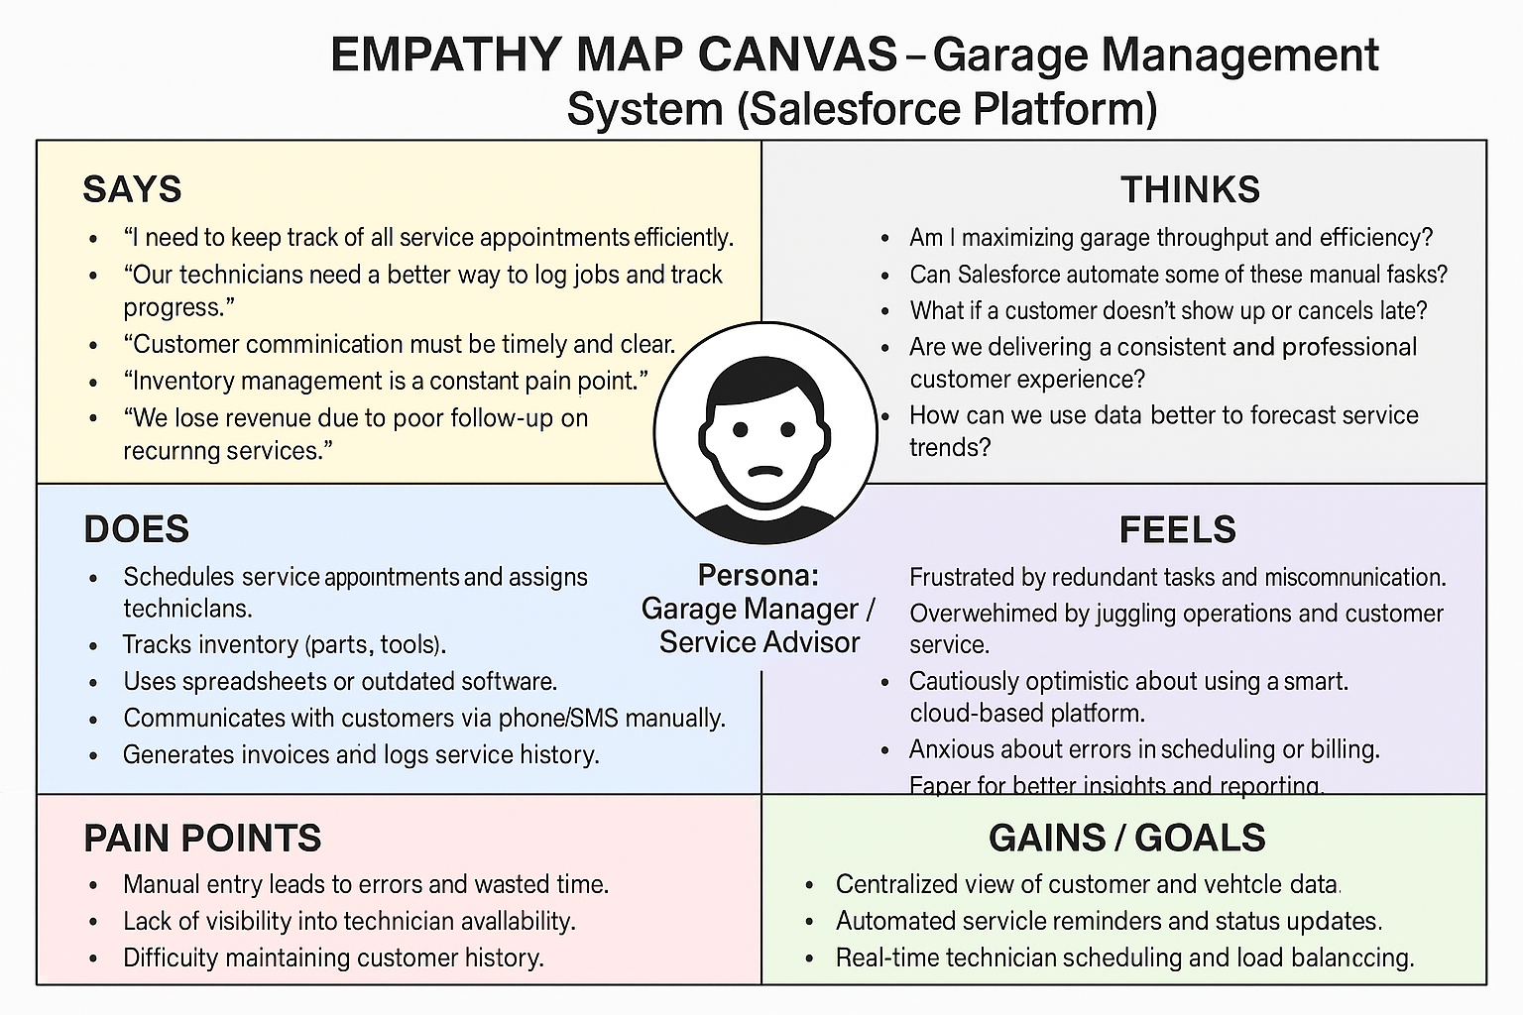

## 2.3 Brainstorming

|  |  |
| --- | --- |
| Date | 02 July 2025 |
| Team ID | LTVIP2025TMID31345 |
| Project Name | Garage Management System |
| Maximum Marks | 4 Marks |

• How might we automate appointment scheduling to avoid conflicts and no-shows?

• How might we give technicians real-time access to job orders and parts?

• How might we centralize vehicle and customer histories for quick service decisions?

• How might we notify customers proactively about service updates?

• How might we simplify inventory tracking and restocking?

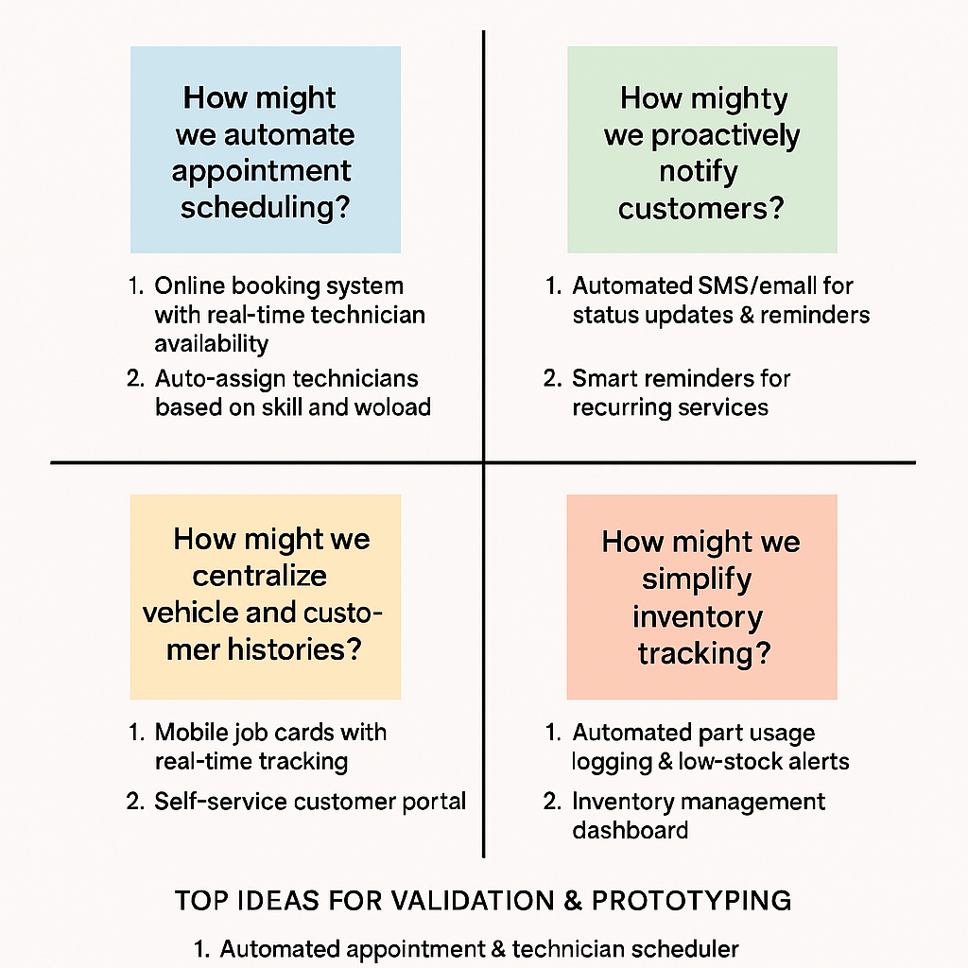

# 3. REQUIREMENT ANALYSIS

## 3.1 Customer Journey map

The customer journey map for the Garage Management System project illustrates the end-to-end experience of a vehicle owner engaging with an automotive service center — from discovering the garage, booking an appointment, receiving service updates, to post-service feedback — with each touchpoint powered by Salesforce tools such as Experience Cloud, Service Cloud, and automated workflows. This map aims to identify customer emotions, pain points, and opportunities at every stage to ensure a seamless, transparent, and customer-centric service experience.

1.**Awareness & Discovery**– Customer finds garage via website/portal (Experience Cloud)

2.**Appointment Booking**– Easy self-service scheduling with real-time availability (Flow + Calendar Integration)

**3.Service Drop-off & Updates**– Real-time notifications and status updates (Flow + Email/SMS Integration)

**4.Service Completion & Billing**– Instant invoice generation and digital payment options (Custom Objects + Third-Party Integration)

**5.Follow-Up & Loyalty**– Automated follow-ups, feedback collection, and loyalty offers (Automation Studio or Flow)

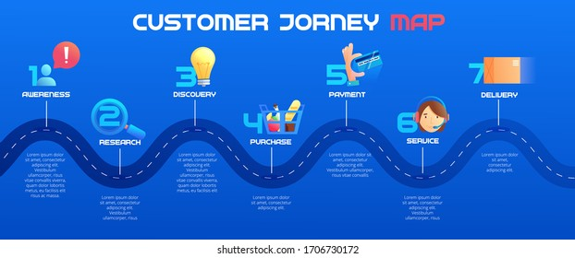

**3.2 Solution Requirement**

|  |  |
| --- | --- |
| Date | 02 July 2025 |
| Team ID | LTVIP2025TMID31345 |
| Project Name | Garage Management System |
| Maximum Marks | 4 Marks |

**Functional Requirements:**

The solution for the Garage Management System must deliver a fully integrated, cloud-based platform—built on Salesforce—that streamlines core garage operations, enhances customer experience, and provides real-time insights. The system must support appointment scheduling, service tracking, inventory management, customer communication, technician coordination, and post-service engagement, while being scalable, user-friendly, and mobile-accessible.

**1. Appointment Scheduling & Management**

• Real-time booking with technician/bay availability

• Calendar view for service advisors

**2. Customer & Vehicle Data Management**

• Centralized CRM with full service history and contact details

• Ability to link vehicles to owners and previous jobs

**3. Inventory & Parts Management**

• Stock level tracking, usage logging, and automated restocking triggers

**4. Customer Communication Automation**

• SMS/email updates, appointment reminders, and service confirmations

• Post-service surveys and feedback collection

**5. Billing & Invoicing Integration**

• Automatic invoice generation

• Optional payment gateway integration (e.g., Stripe, Razorpay)

**6. Reporting & Analytics**

• Dashboards for service trends, revenue, technician performance, and inventory flow

## 3.3 Data Flow Diagram

|  |  |
| --- | --- |
| Date | 02 July 2025 |
| Team ID | LTVIP2025TMID31345 |
| Project Name | Garage Management System |
| Maximum Marks | 4 Marks |

The Data Flow Diagram (DFD) for the Garage Management System illustrates how data moves between users, processes, and data stores within the Salesforce platform. It captures the interactions between customers, service advisors, technicians, and backend systems, showing how information like appointments, customer profiles, job cards, inventory levels, and invoices is created, accessed, updated, and stored. This visual representation ensures a shared understanding of system workflows and supports the efficient design of automated, integrated, and secure data handling within the Salesforce ecosystem.

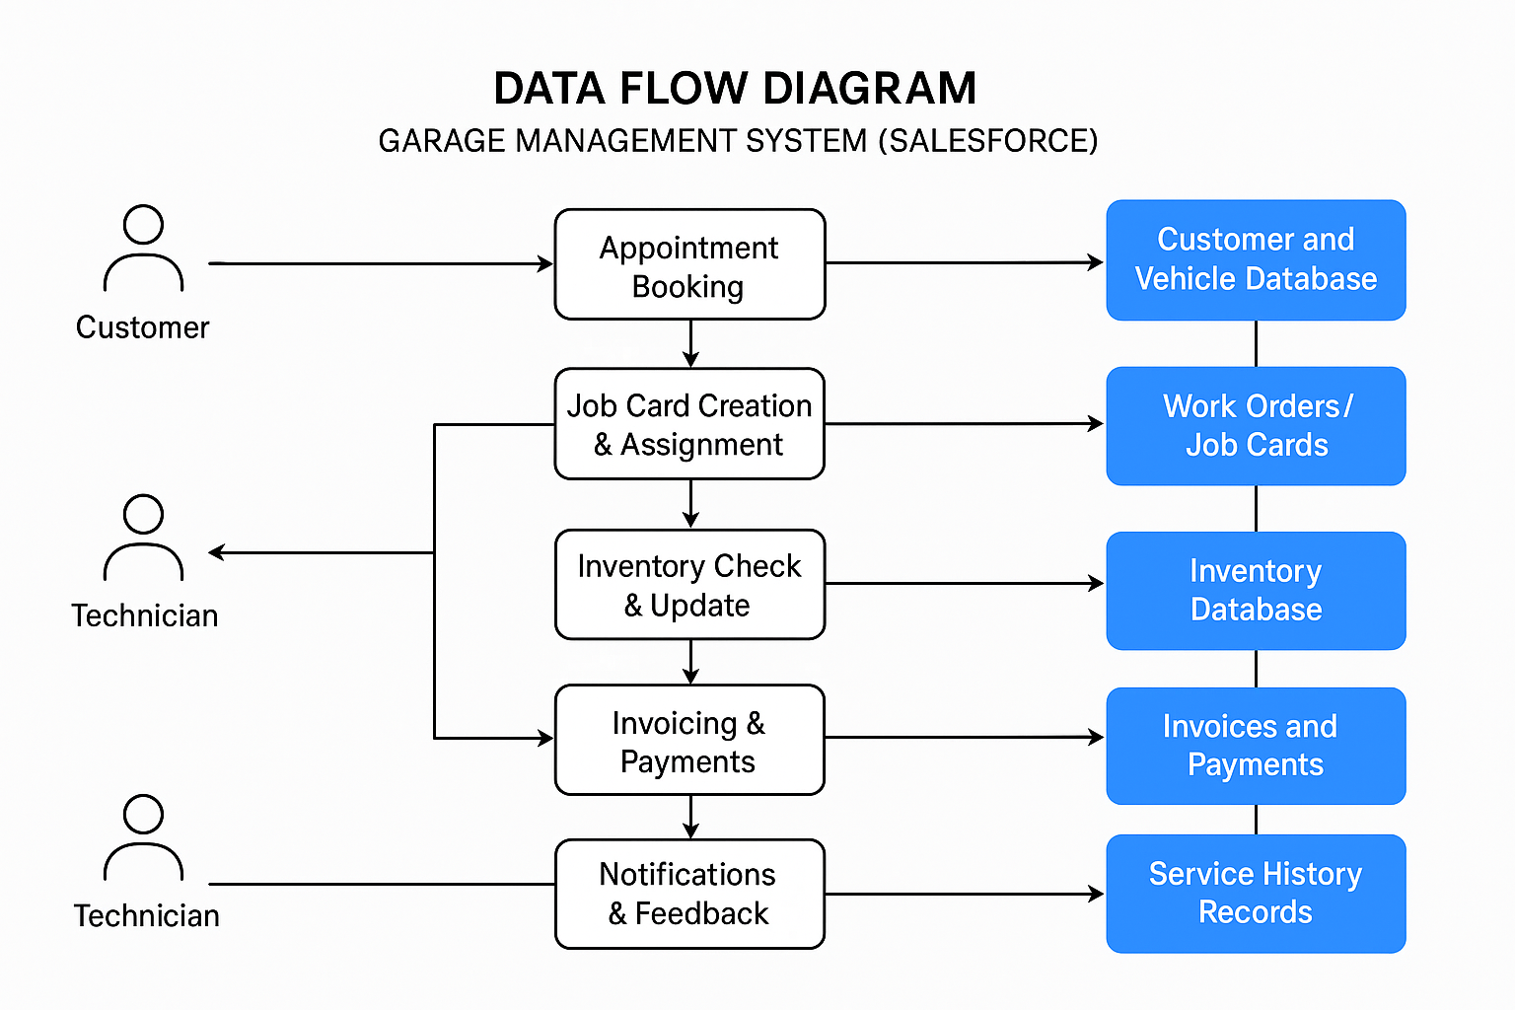

Caption

## 3.4 Technology Stack

|  |  |
| --- | --- |
| Date | 02 July 2025 |
| Team ID | LTVIP2025TMID31345 |
| Project Name | Garage Management System |
| Maximum Marks | 4 Marks |

The technology stack for the Garage Management System project leverages the Salesforce platform’s robust cloud infrastructure, combining low-code tools, automation engines, customer-facing portals, and analytics to deliver a scalable, user-friendly, and intelligent solution. The system is built using native Salesforce technologies along with optional third-party integrations to enhance functionality and user experience.

|  |  |  |
| --- | --- | --- |
| **Layer** | **Technology** | **Purpose** |
| **Platform & Data** | Salesforce Core CRM (Objects, Schema Builder) | Manage data models (Customers, Vehicles, Jobs, Inventory) |
| **Automation** | Salesforce Flow, Process Builder, Apex Triggers | Automate processes (notifications, assignments, billing) |
| **Service Management** | Service Cloud, Field Service Lightning (FSL) | Job assignments, technician tracking, work orders |
| **Customer Interface** | Experience Cloud | Self-service portal for booking, status, feedback |

# 4. PROJECT DESIGN

## 4.1 Problem Solution Fit

|  |  |
| --- | --- |
| Date | 02 July 2025 |
| Team ID | LTVIP2025TMID31345 |
| Project Name | Garage Management System |
| Maximum Marks | 4 Marks |

The project design for the Garage Management System leverages the Salesforce platform’s modular architecture to create a scalable, user-friendly, and process-driven solution that streamlines automotive service operations. The design focuses on mapping user journeys, automating workflows, and integrating key service processes through a combination of standard Salesforce objects, custom components, and low-code automation. The system ensures real-time access to data, mobile usability for technicians, and an intuitive portal for customers — all built securely within Salesforce’s cloud ecosystem.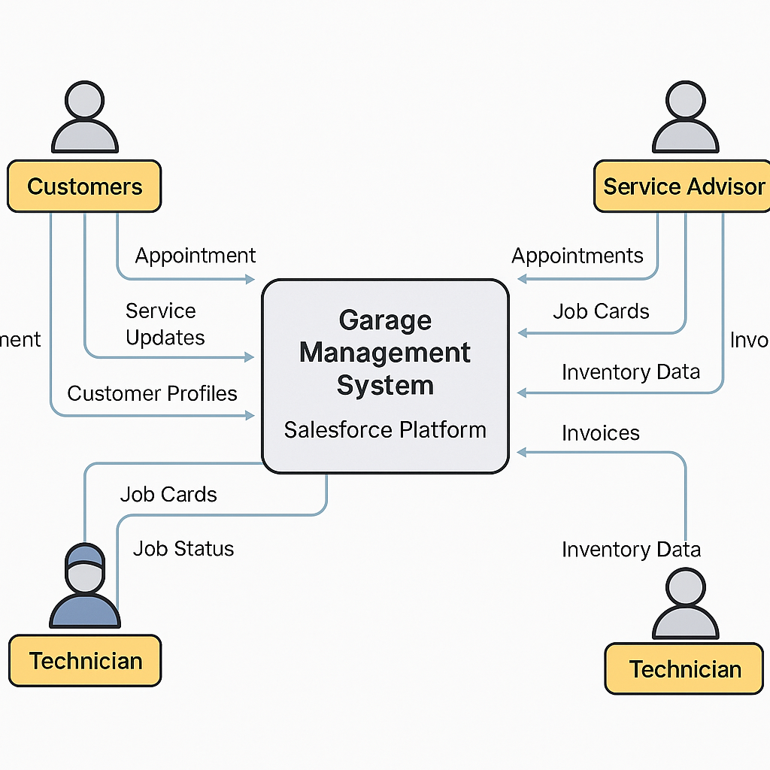

## 4.2 Proposed Solution

The proposed solution for the Garage Management System is a cloud-based, end-to-end application built on the Salesforce platform that streamlines garage operations, enhances customer service, and provides real-time visibility into job and inventory statuses. Leveraging Salesforce’s CRM capabilities, automation tools, and customer portal functionality, the system will centralize key processes such as appointment scheduling, job card management, technician assignment, inventory tracking, invoicing, and customer engagement. The solution is designed to be mobile-responsive, secure, and scalable to support both small and multi-location garages.

**1. Appointment Scheduling System**

• Real-time booking based on technician and bay availability

• Calendar views for service advisors

**2. Technician & Job Management**

• Digital job cards with task tracking and status updates

• Technician dashboard and mobile access via Salesforce Field Service

**3. Inventory & Parts Control**

• Stock level tracking, alerts for low inventory, and usage logging

• Integration with products/custom inventory objects

**4. Customer Self-Service Portal**

• Built on Salesforce Experience Cloud

• Enables customers to book, view history, and track service status

**5. Billing & Invoicing**

• Auto-generated invoices based on completed jobs

• Optional online payment gateway integration

## 4.3 Solution Architecture

|  |  |
| --- | --- |
| Date | 02 July 2025 |
| Team ID | LTVIP2025TMID31345 |
| Project Name | Garage Management System |
| Maximum Marks | 4 Marks |

The solution architecture for the Garage Management System is designed to deliver a modular, secure, and scalable application using Salesforce’s multi-cloud capabilities. The architecture integrates Salesforce Core CRM, Service Cloud, Field Service Lightning, and Experience Cloud to support seamless workflows across customers, technicians, service advisors, and inventory managers. The system ensures real-time process automation, centralized data storage, responsive interfaces, and mobile access—while enabling integration with third-party tools for communication, payments, and reporting. The architecture emphasizes user role separation, process automation, and extensibility to adapt to multi-location garage operations.

**1. Presentation Layer**

•Experience Cloud: Customer self-service portal (booking, job tracking, feedback)

•Lightning App Builder: Custom UI for internal staff (service advisors, managers)

•Salesforce Mobile App / Field Service App: Technician access to job cards and tasks

**2. Application Layer**

•Salesforce Flows & Apex: Automation of service assignments, alerts, approvals, and notifications

•Field Service Lightning (FSL): Scheduling, dispatching, and tracking technician jobs

•Process Builder / Workflow Rules: Lightweight automation for standard tasks

•LWC (Lightning Web Components): Custom UI for complex screens like dashboards or dynamic job cards

**3. Data Layer**

•Standard Objects: Account, Contact, Case, Product

•Custom Objects: Vehicle, Job Card, Service Request, Inventory Item, Invoice

•Data Relationships: Proper lookup/master-detail connections to ensure data integrity

# 5. PROJECT PLANNING & SCHEDULING

## 5.1 Project Planning

## The project planning for the Garage Management System focuses on delivering a structured, agile, and phased approach to building a robust, cloud-based solution using the Salesforce platform. The plan is designed to ensure successful delivery of key features such as appointment scheduling, job card management, technician workflows, inventory tracking, billing, and customer engagement. The planning process incorporates clear milestones, stakeholder alignment, resource allocation, sprint-based development, testing phases, and deployment strategies to ensure timely delivery, risk mitigation, and quality assurance.

1. Project Phases & Timeline:

• Phase 1: Discovery & Requirement Gathering

• Stakeholder interviews, use case identification, platform scope definition

• Phase 2: Solution Design

• Data modeling, process flows, security roles, UI/UX mockups

• Phase 3: Development & Configuration

• Salesforce object setup, automation flows, LWC components, integrations

• Phase 4: Testing & QA

• Unit testing, UAT, bug fixing, validation against business requirements

• Phase 5: Deployment & Go-Live

• Sandbox to production migration, end-user training, system launch

• Phase 6: Post-Go-Live Support

• Monitoring, feedback collection, iteration planning

# 6. FUNCTIONAL AND PERFORMANCE TESTING

## 6.1 Performance Testing

|  |  |
| --- | --- |
| Date | 02 July 2025 |
| Team ID | LTVIP2025TMID31345 |
| Project Name | Garage Management System |
| Maximum Marks | 4 Marks |

“Functional and performance testing for the Garage Management System ensures that all components of the application—developed on the Salesforce platform—operate correctly under expected and peak conditions. The functional testing focuses on validating user workflows, data accuracy, system automation, and business logic, while performance testing evaluates the system’s responsiveness, stability, and scalability under varying load conditions. Both testing strategies aim to deliver a reliable, efficient, and user-friendly experience for service advisors, technicians, and customers using Salesforce’s robust development and deployment capabilities.

**Tools & Techniques:**

•Salesforce Inspector, Developer Console – Debugging and log analysis

•JMeter or BlazeMeter (for Experience Cloud load testing)

•Postman / REST Clients – API integration validation

•Test Automation – Selenium or Provar (for regression and UI test automation)

# 7. RESULTS

## 7.1 Output Screenshots:

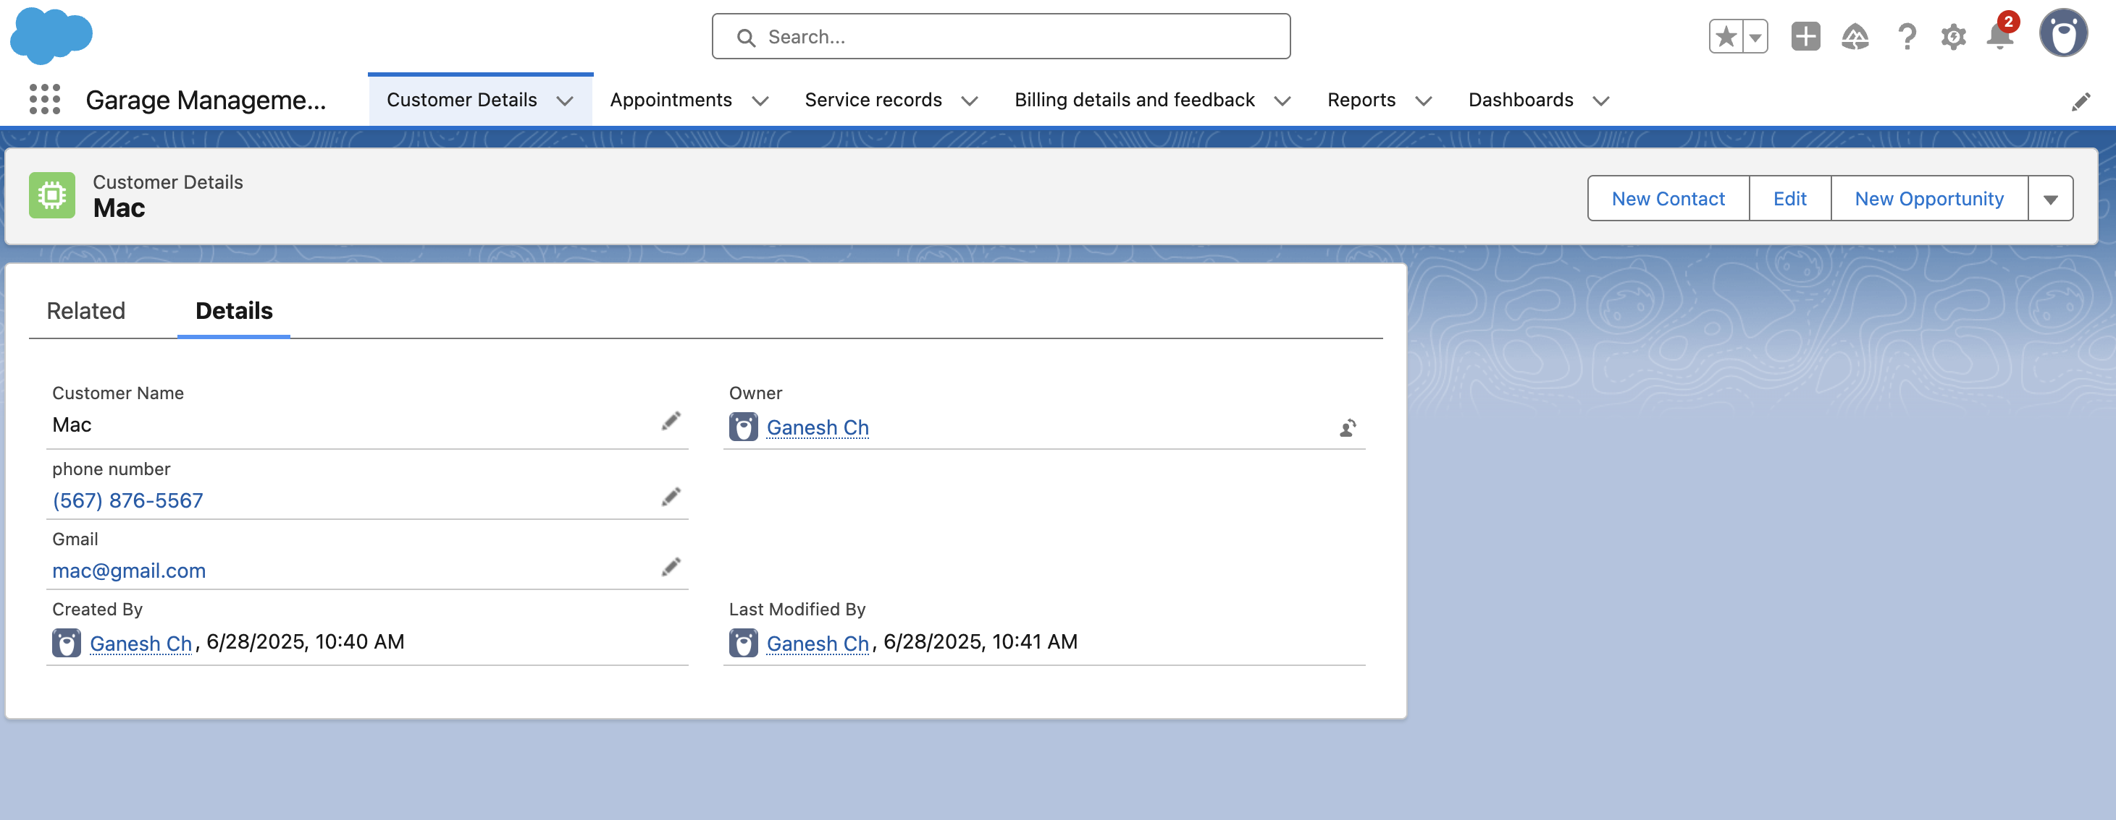

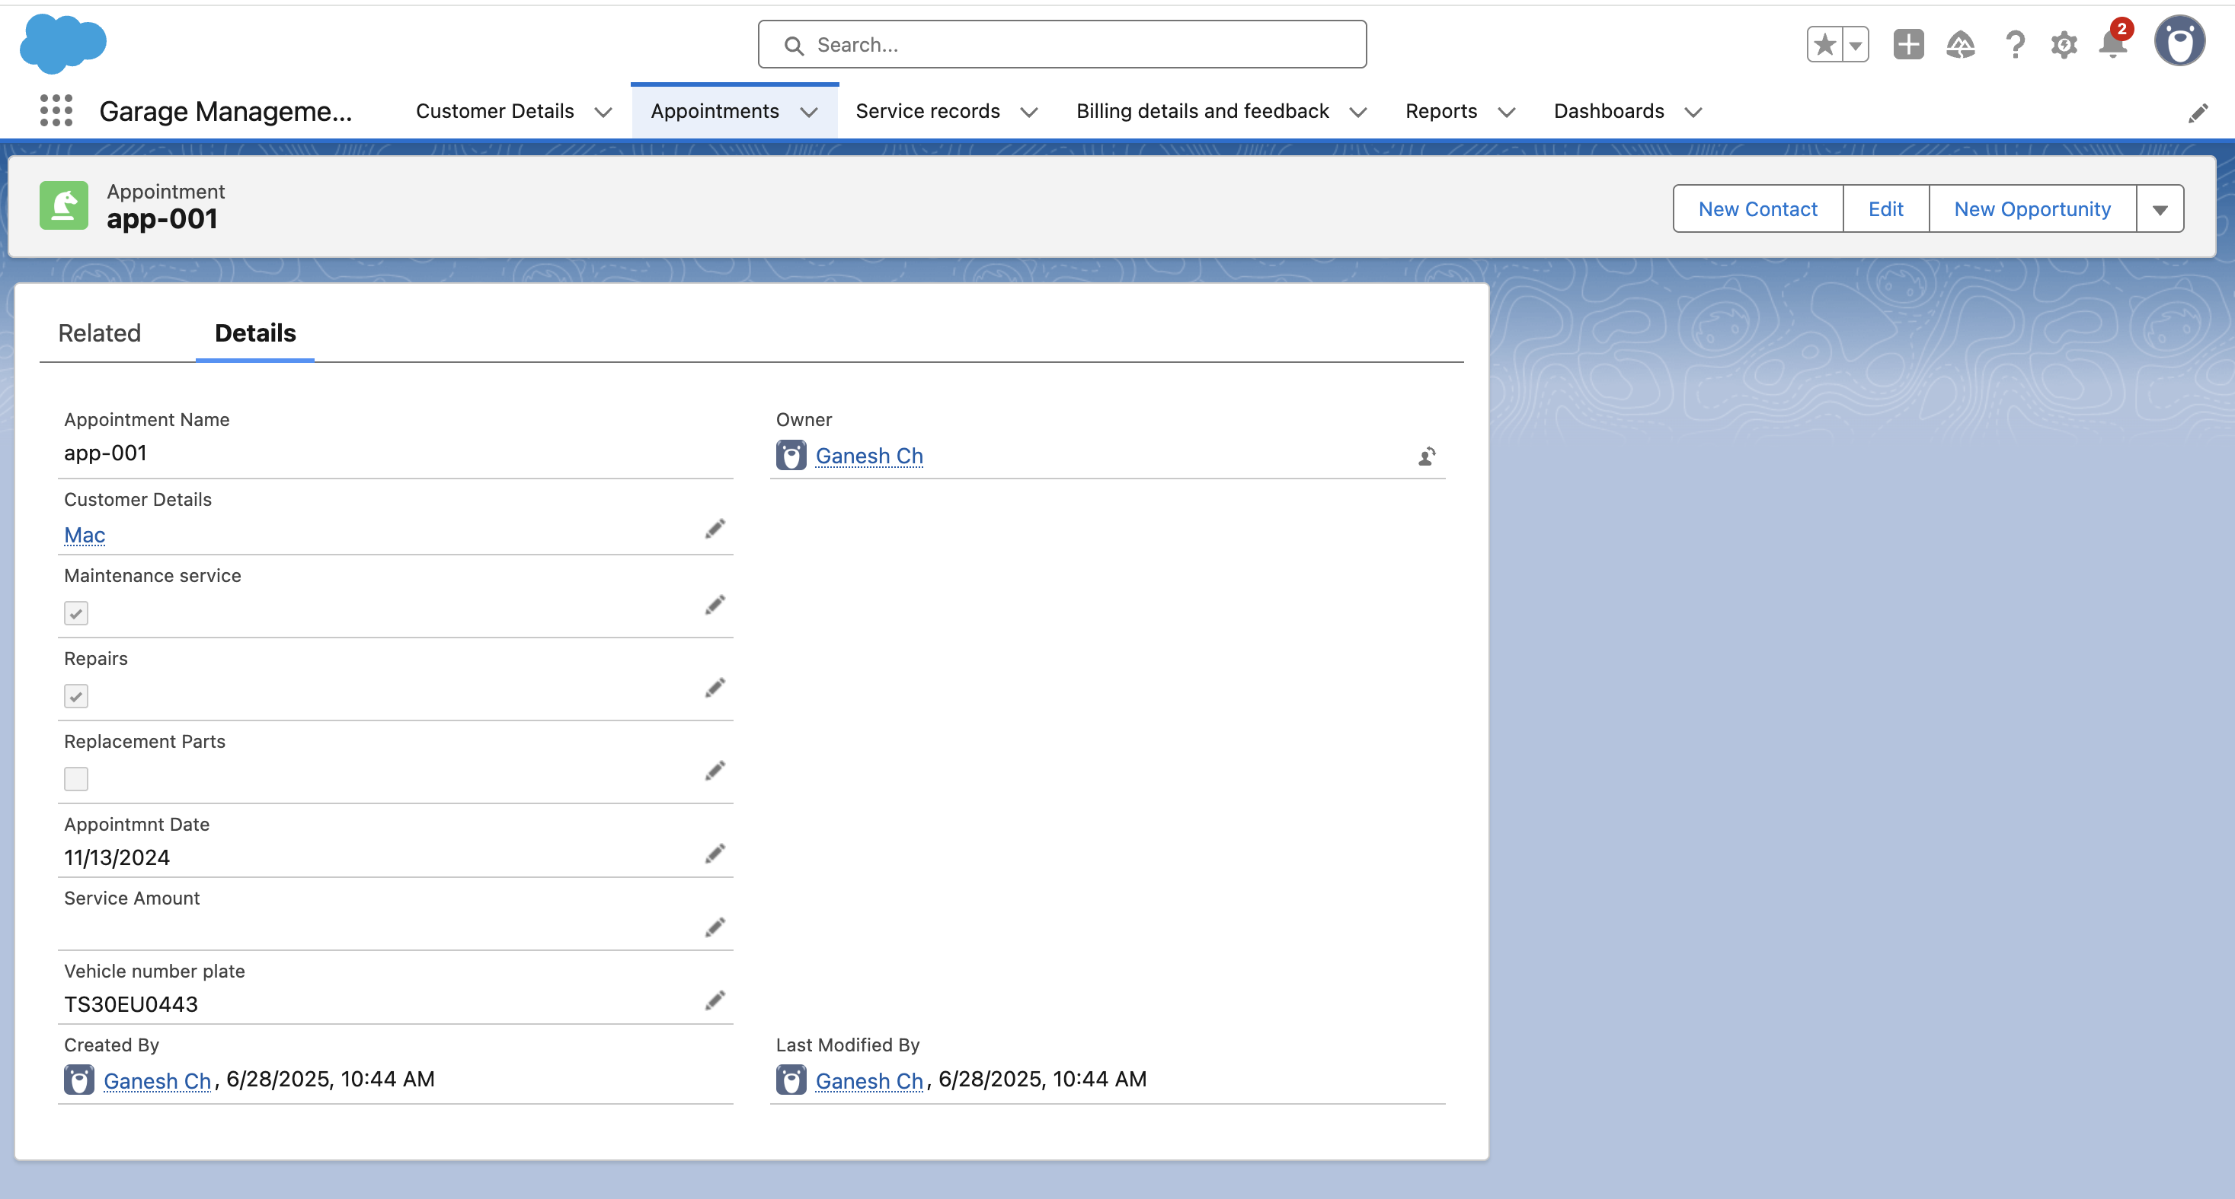

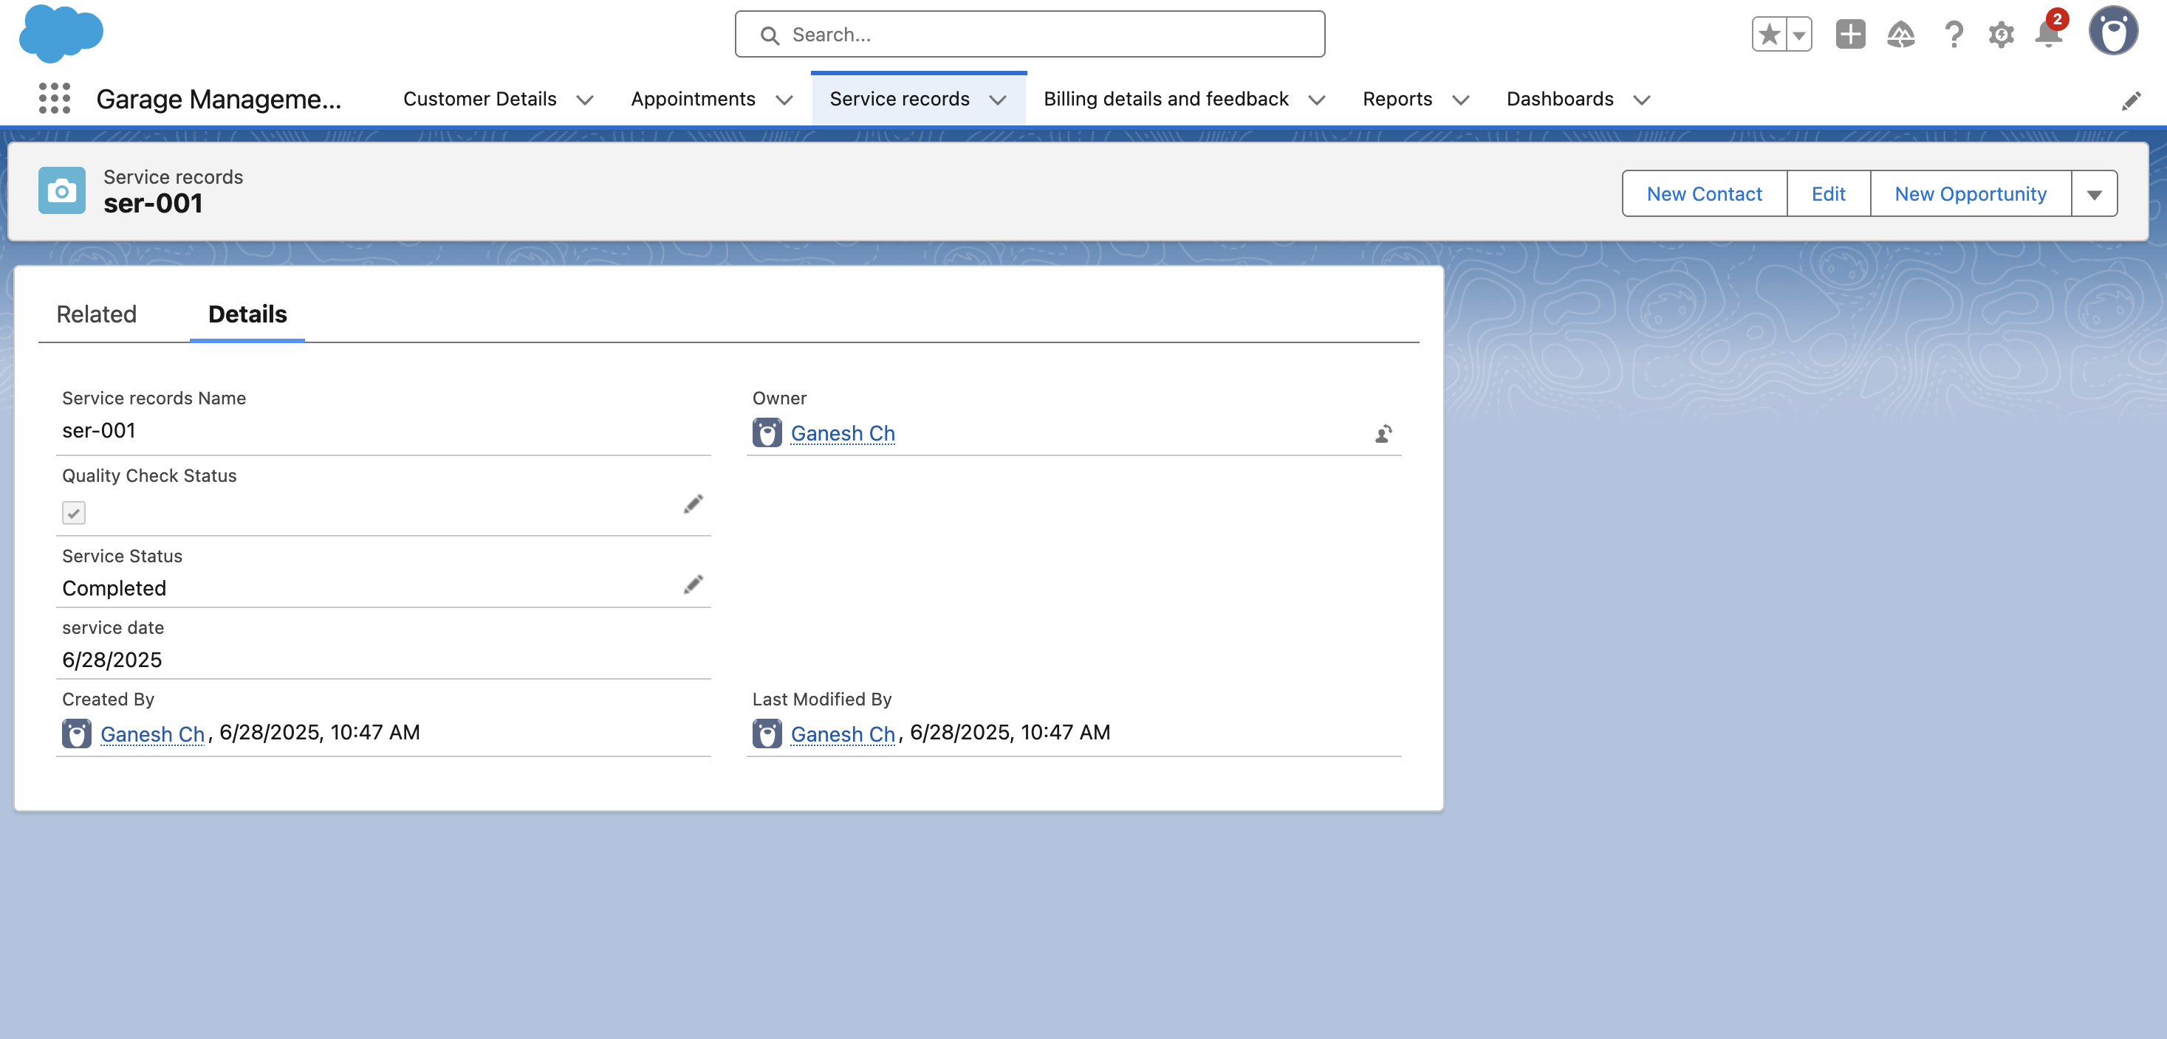

# 8. ADVANTAGES & DISADVANTAGES

# Advantages:

**1. Improved Operational Efficiency**

• Automates daily tasks such as job card creation, appointment scheduling, and invoicing

• Reduces human error and paperwork

**2. Enhanced Customer Experience**

• Enables service tracking, real-time updates, SMS/email notifications, and online booking

• Improves transparency and customer trust

**3. Better Inventory Management**

• Tracks spare parts, consumables, and stock levels

• Prevents overstocking and stockouts with alerts and reports

**4. Centralized Data Management**

• All customer, vehicle, service, and billing data stored in one system

• Easier to retrieve history for warranty, repeat service, or reporting

**5. Real-Time Reporting and Analytics**

• Provides performance metrics such as revenue, technician productivity, and service frequency

• Supports better business decisions with data-driven insights

**6. Workforce Optimization**

• Assigns jobs to technicians based on availability and skill

• Tracks time spent and service quality for performance reviews

**7. Cost Reduction Over Time**

• Saves costs by reducing administrative workload and optimizing inventory usage

• Prevents revenue loss from missed appointments or service delays

# Disadvantages:

# 1. Initial Setup Cost

•Software development or license purchase, plus setup and configuration, may be expensive for small garages

**2. Staff Training Required**

# •Employees may need time and training to adapt to new tools and workflows

# 3. Dependency on Technology

# • Downtime due to software or hardware failure can disrupt operations

# • Requires regular maintenance and technical support

# 4. Data Security Concerns

# • Risk of data breaches or loss if proper security measures are not in place

# • Sensitive customer and payment data needs secure handling

# 5. Customization Complexity

# • Off-the-shelf systems may not fully meet specific garage workflows or multi-location needs

# • Custom development takes time and technical expertise

# 6. Internet Dependency (for cloud systems)

# • If hosted online, internet issues can affect access to the system

# • Remote or rural areas may face connectivity challenges

## 

# 9. CONCLUSION

The Garage Management System project is a transformative solution aimed at modernizing and streamlining the operational workflow of automotive service centers. By digitizing critical processes such as appointment booking, job card management, technician assignments, inventory tracking, and billing, the system enhances both efficiency and customer satisfaction.

Whether deployed on a custom-built platform or through a robust ecosystem like Salesforce, the project empowers garage owners and managers with real-time insights, automation capabilities, and data-driven decision-making tools. It also improves transparency and accountability across staff and service interactions.

Ultimately, the Garage Management System lays the foundation for a future-ready, customer-centric, and high-performing automotive service operation.

# 10. FUTURE SCOPE

**1. Integration with IoT and Smart Vehicles**

• Enable real-time diagnostics by integrating with connected vehicles and OBD-II devices

• Automatically detect issues, generate job cards, and order necessary parts in advance

**2. AI-Powered Predictive Maintenance**

• Use machine learning to analyze service history and usage patterns

• Predict future service needs and recommend optimal maintenance schedules

**3. Mobile App Expansion**

• Launch dedicated mobile apps for customers (booking, tracking, payments)

• Mobile apps for technicians with barcode scanning and real-time updates

**4. Advanced Analytics & BI Tools**

• Deeper insights using business intelligence tools (Power BI, Tableau, or Salesforce Einstein)

• Forecast sales, inventory demand, and technician performance

**5. Enhanced Reporting & Custom Dashboards**

• Use Tableau CRM (CRM Analytics) for interactive dashboards and advanced BI

• Track KPIs like average service time, technician efficiency, and customer satisfaction trends

# 11. APPENDIX

**GitHub :-**https://github.com/ganeshch25/Garage-Management-System

**Project Demonstration Link**  :- https://drive.google.com/file/d/1Yds06nJ3PwuQt9WncZEYIHgIyx9c6Tlj/view?usp=drivesdk